Screen Shot Of Code :

EmployeeData(model package):

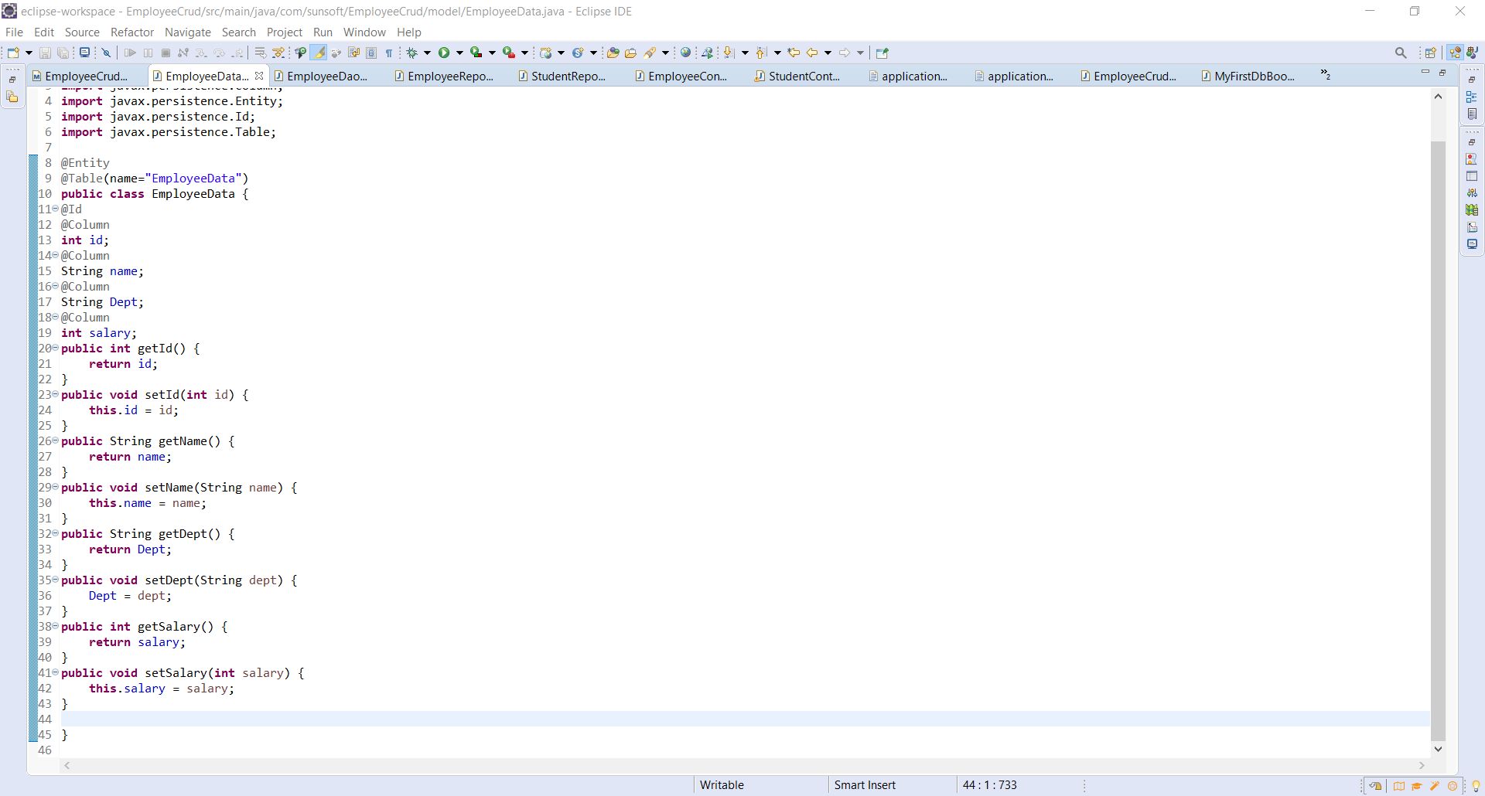

EmployeeRepository(.repository package):

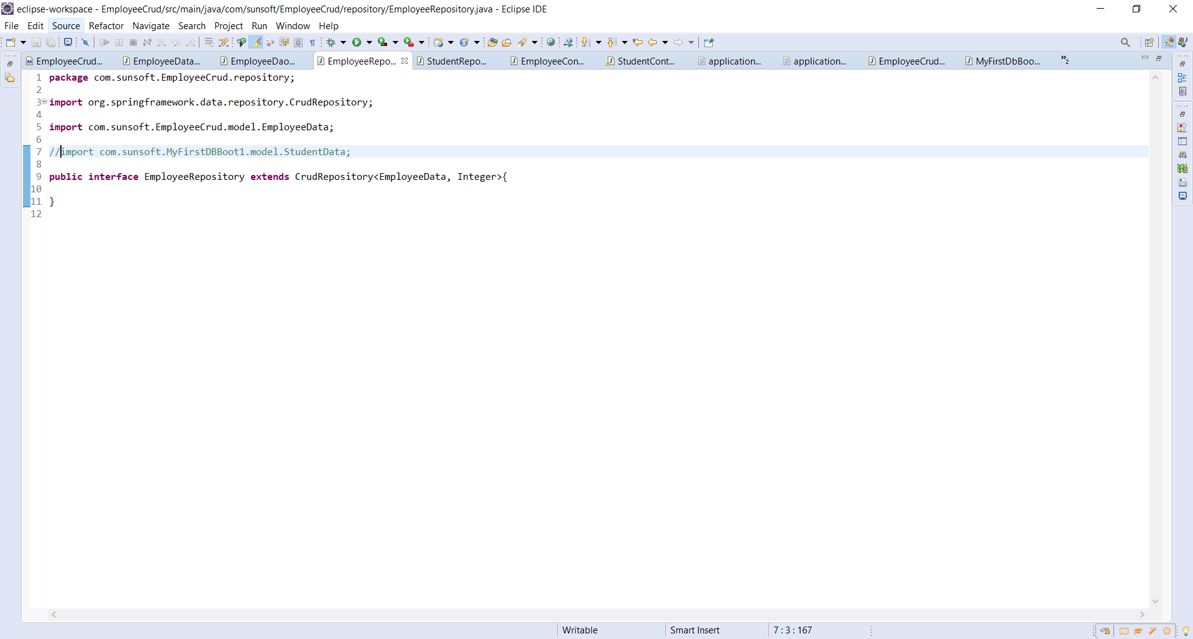

EmployeeDao(.dao package):

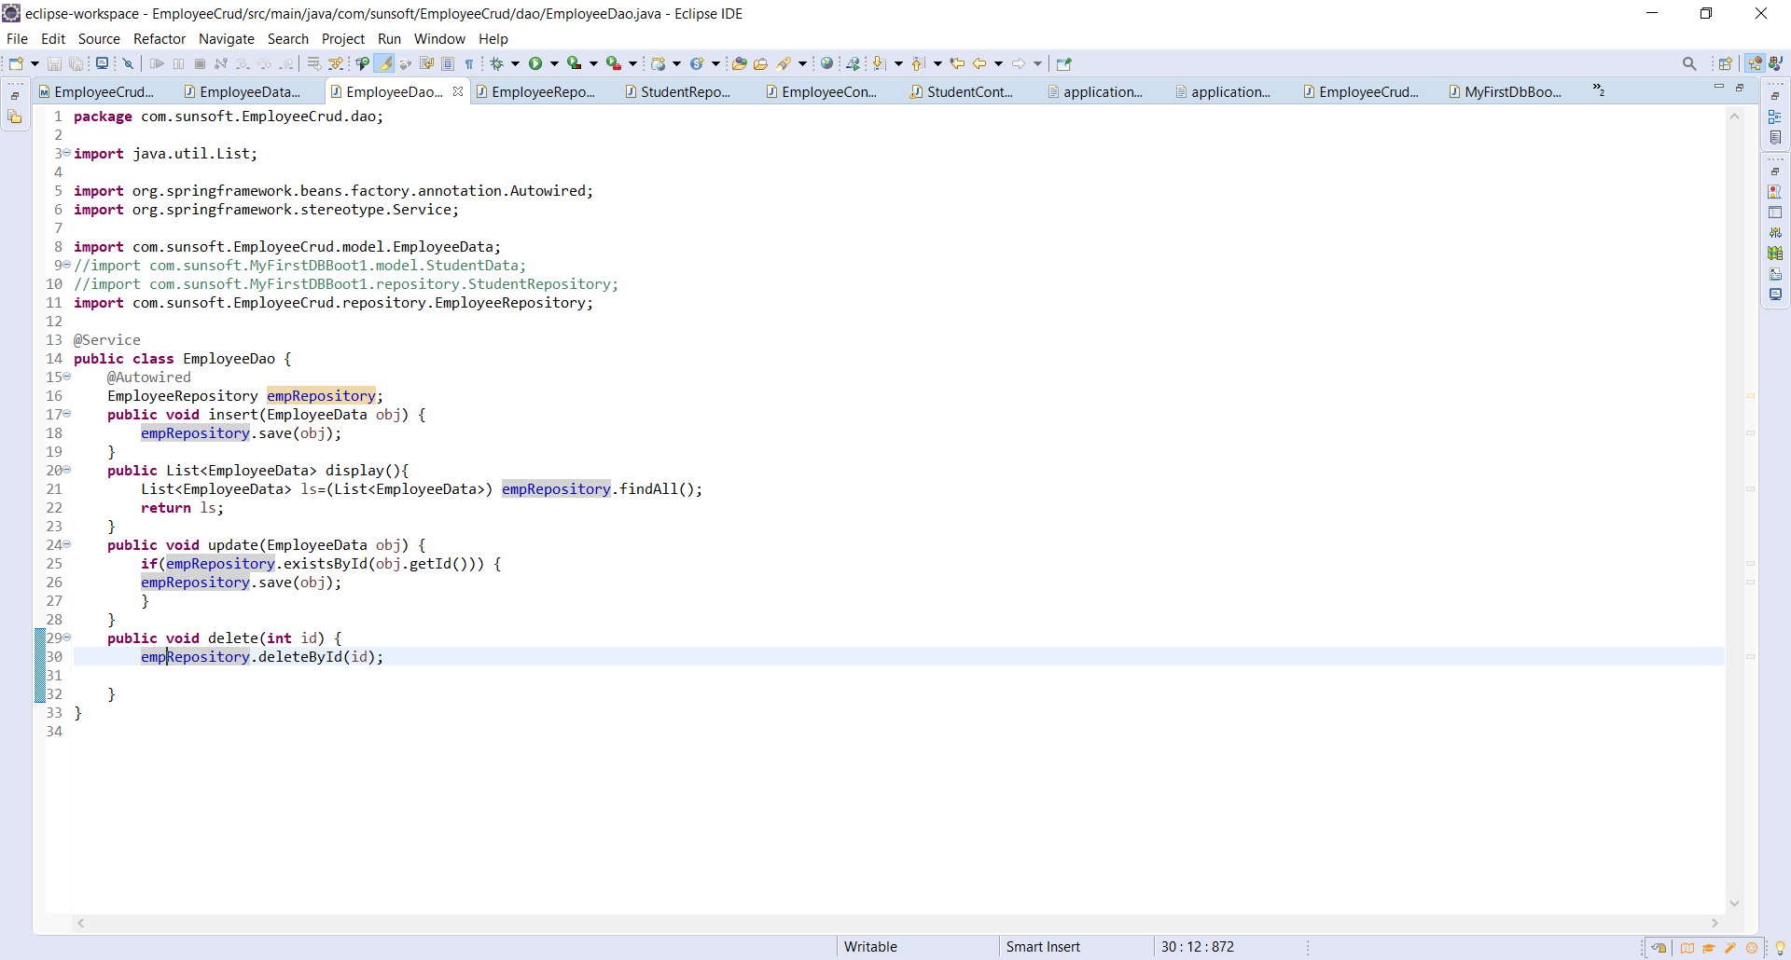

EmployeeController(.controller):

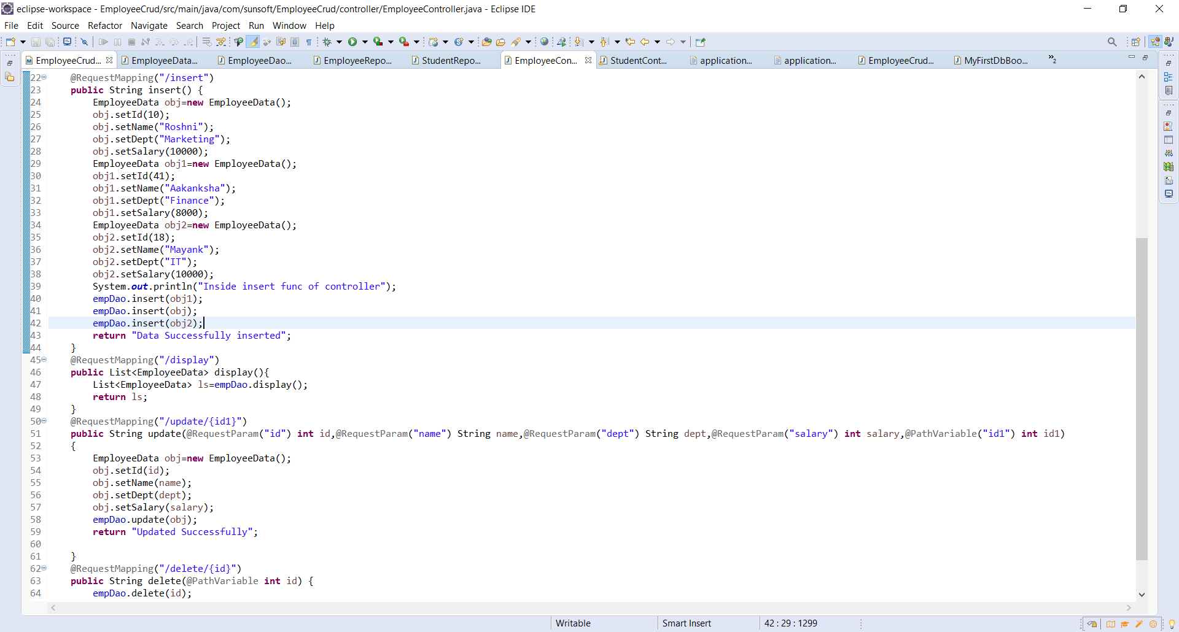

Main Page:

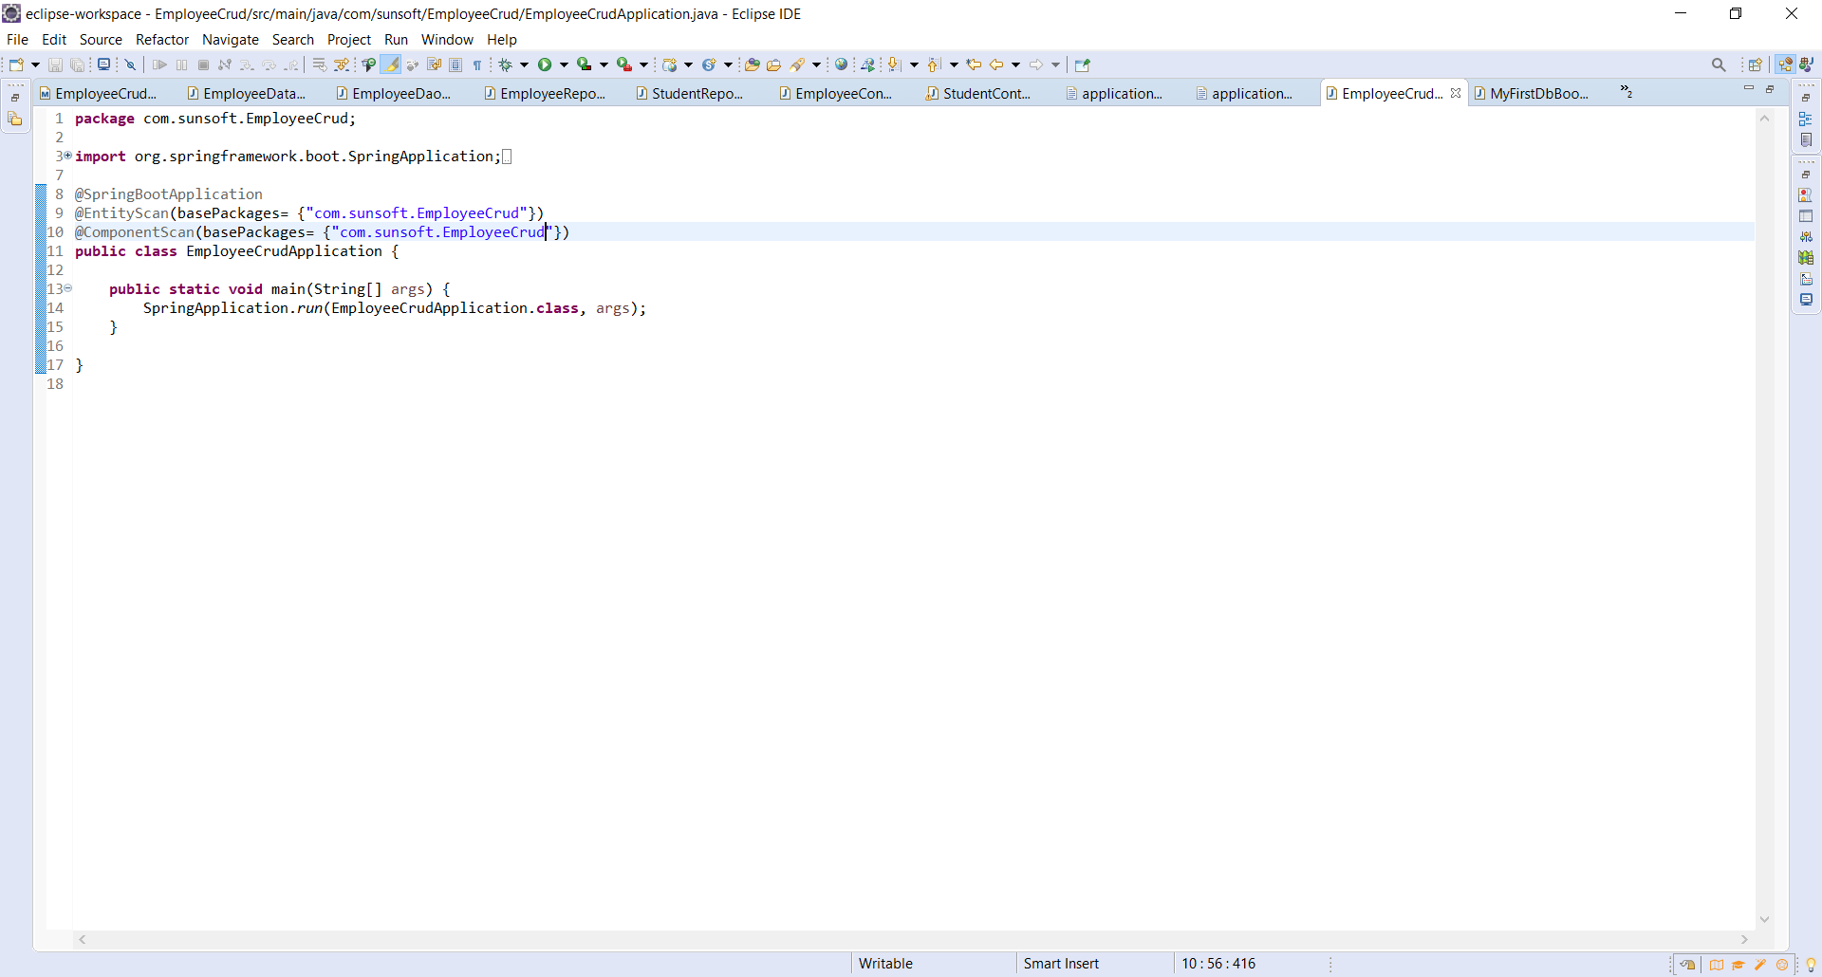

Screenshots of execution:

“/insert” in browser:

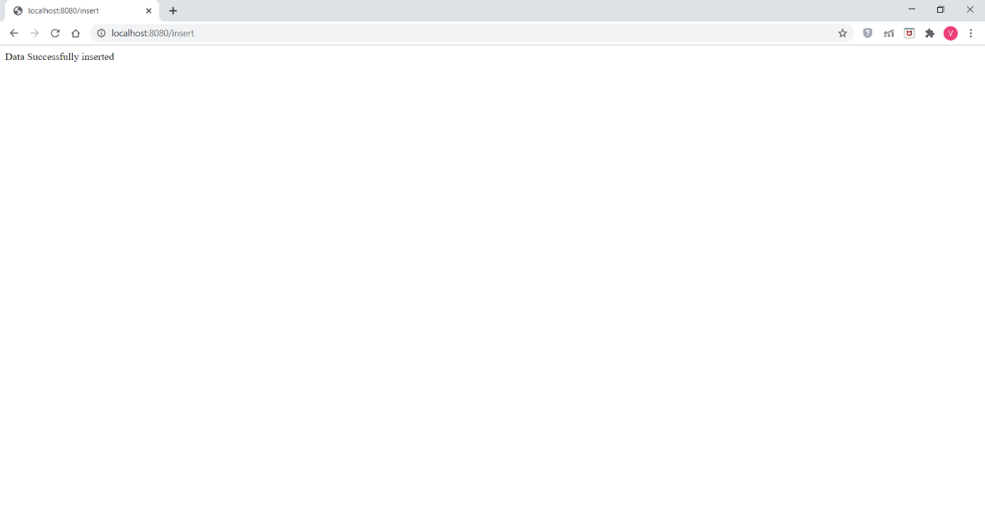

employee_data after Inserting viewed using HeidiSQL:

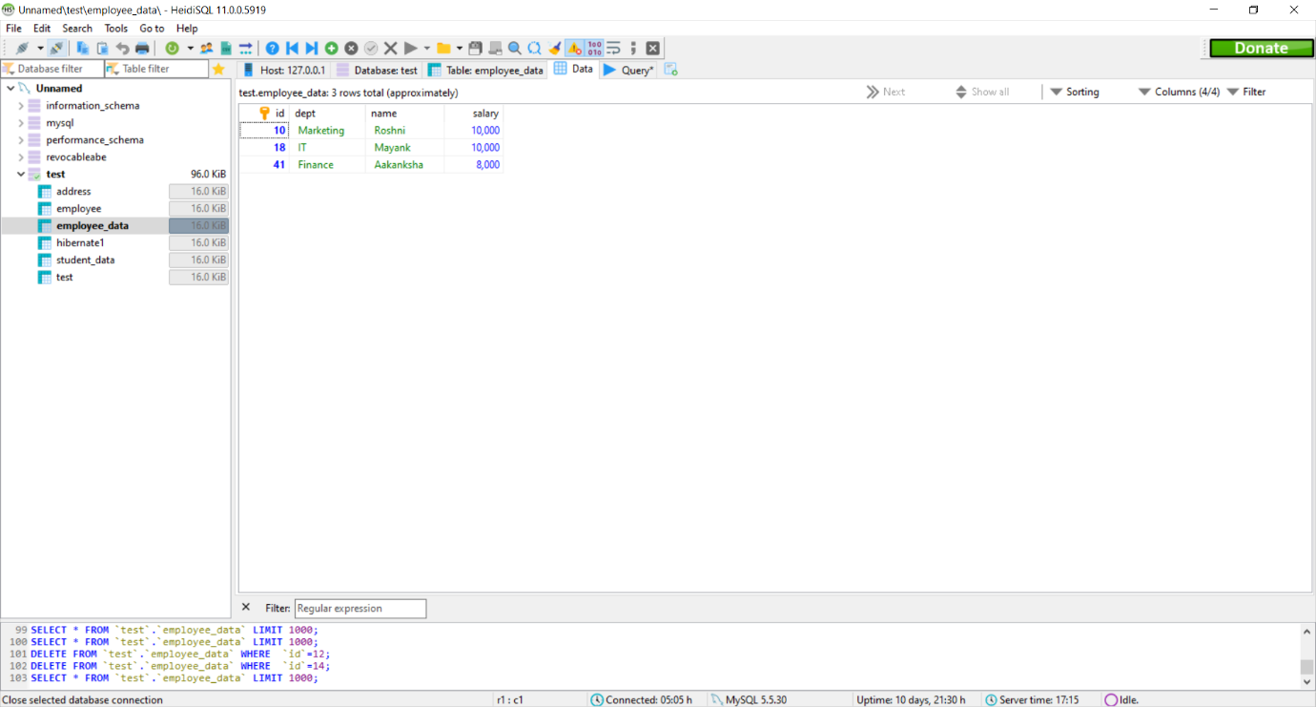

“/display” on browser: It displays all the content of database in JSON format

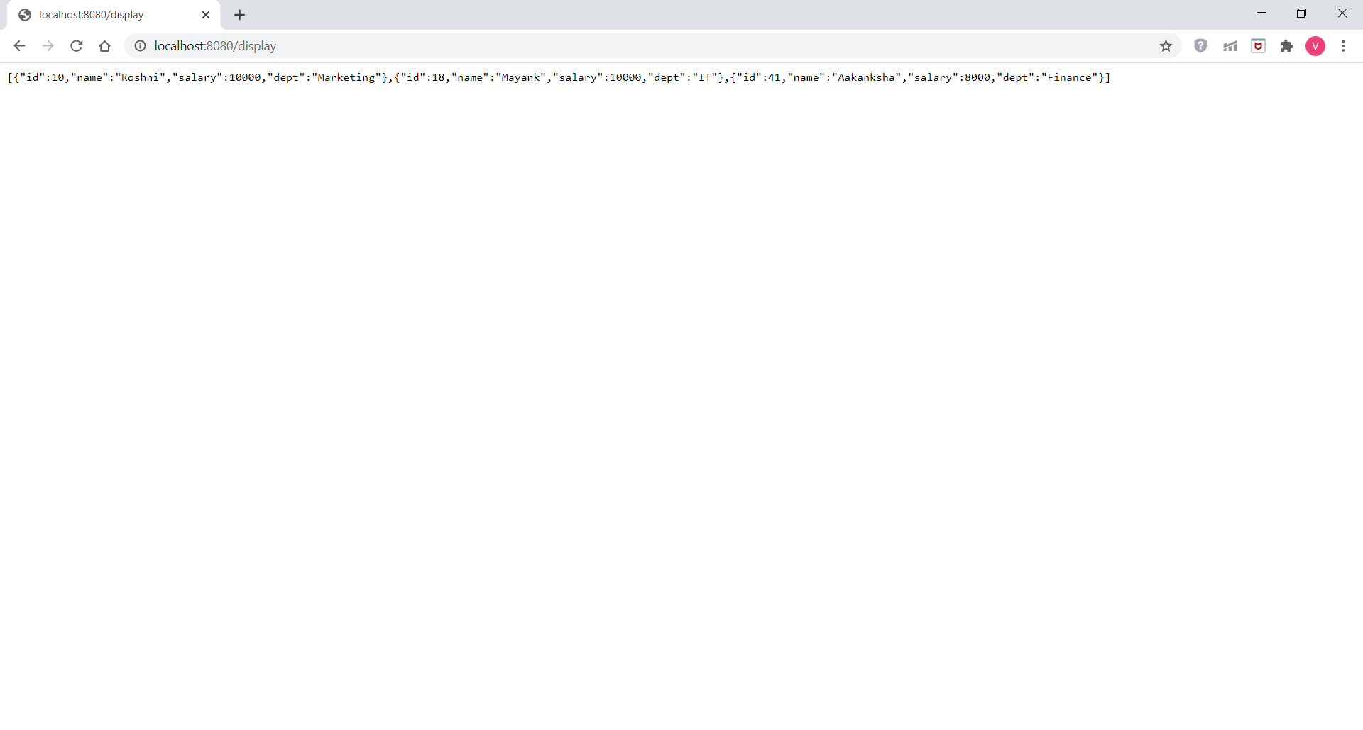

“/delete/{id}” on web browser:

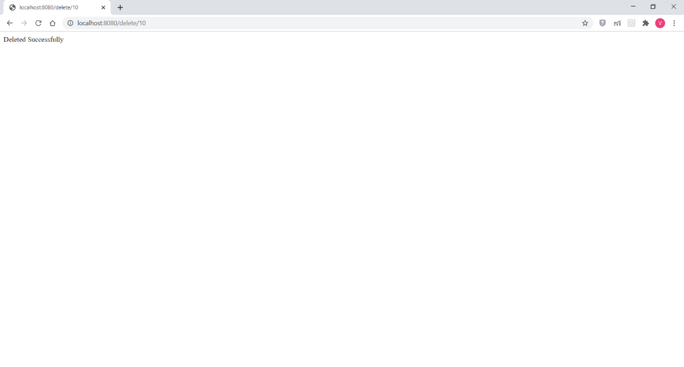

employee_data database after delete operation(after deleting id 10):

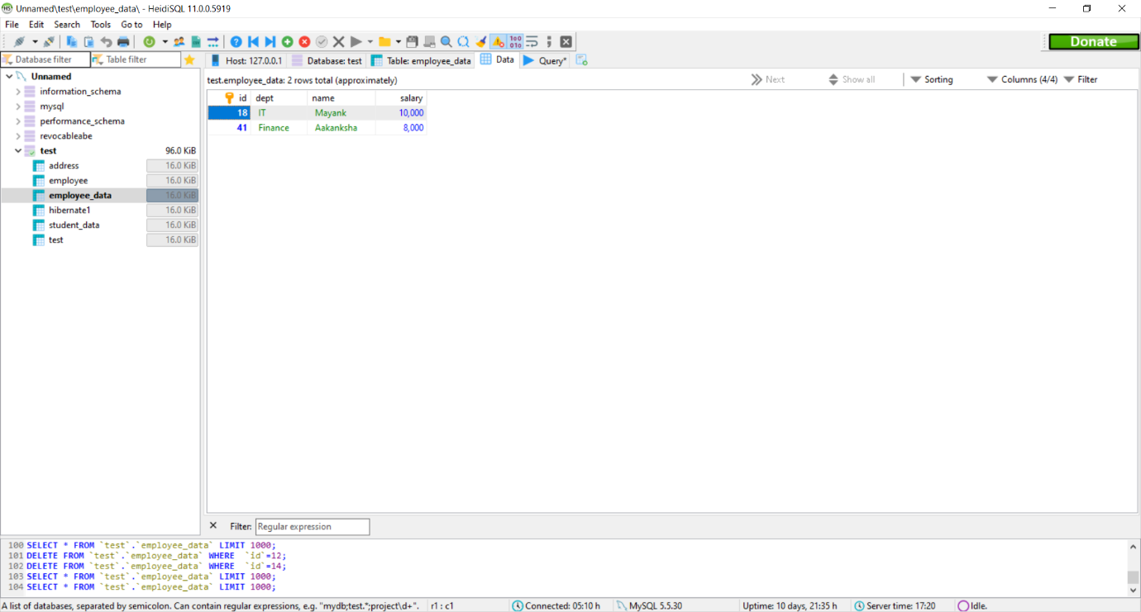

“/update/………” on web browser:

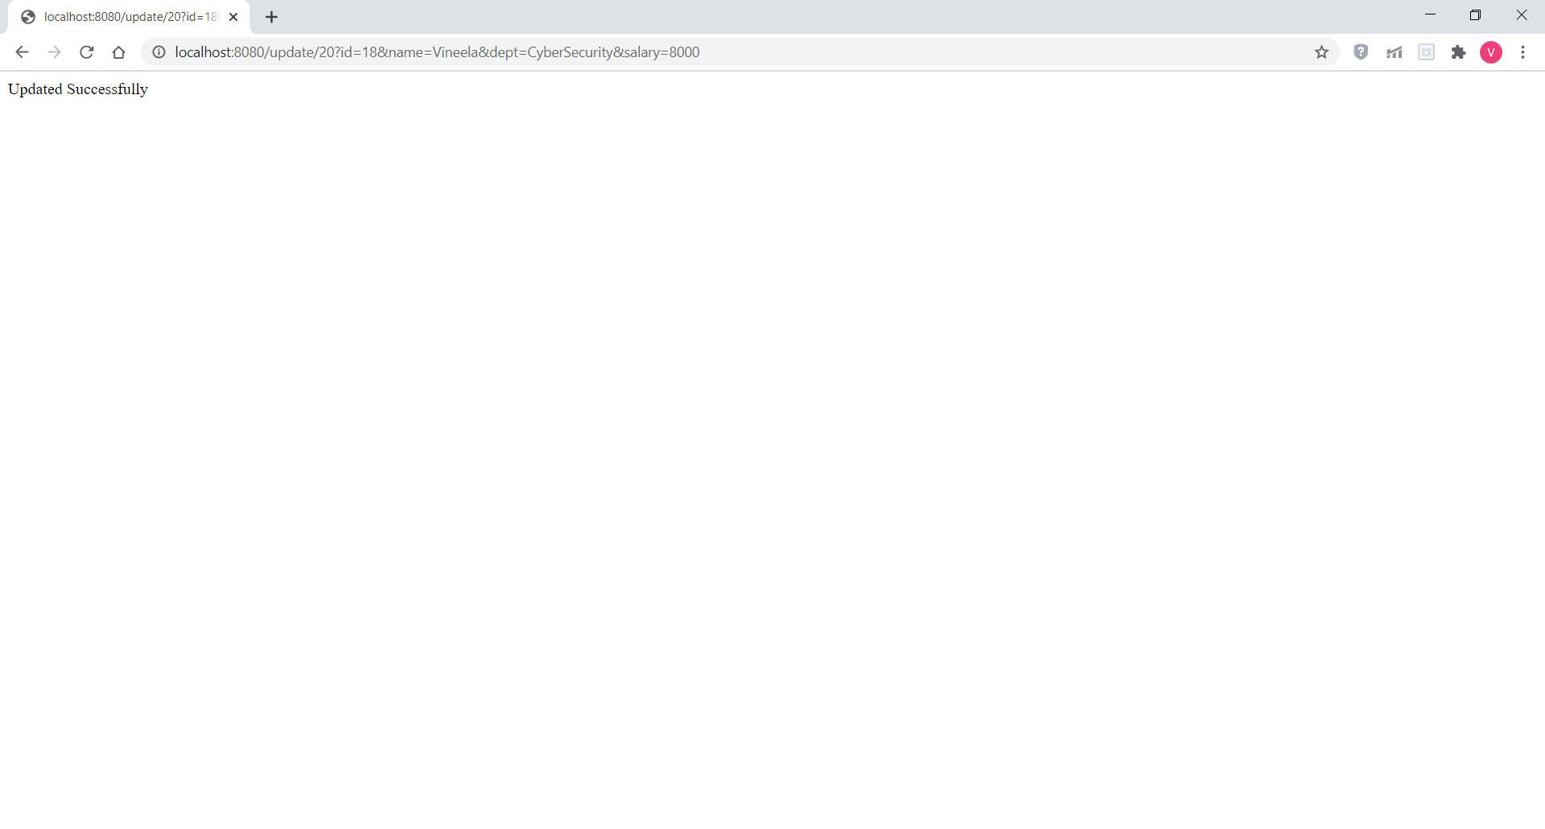

employee_data after update operation:

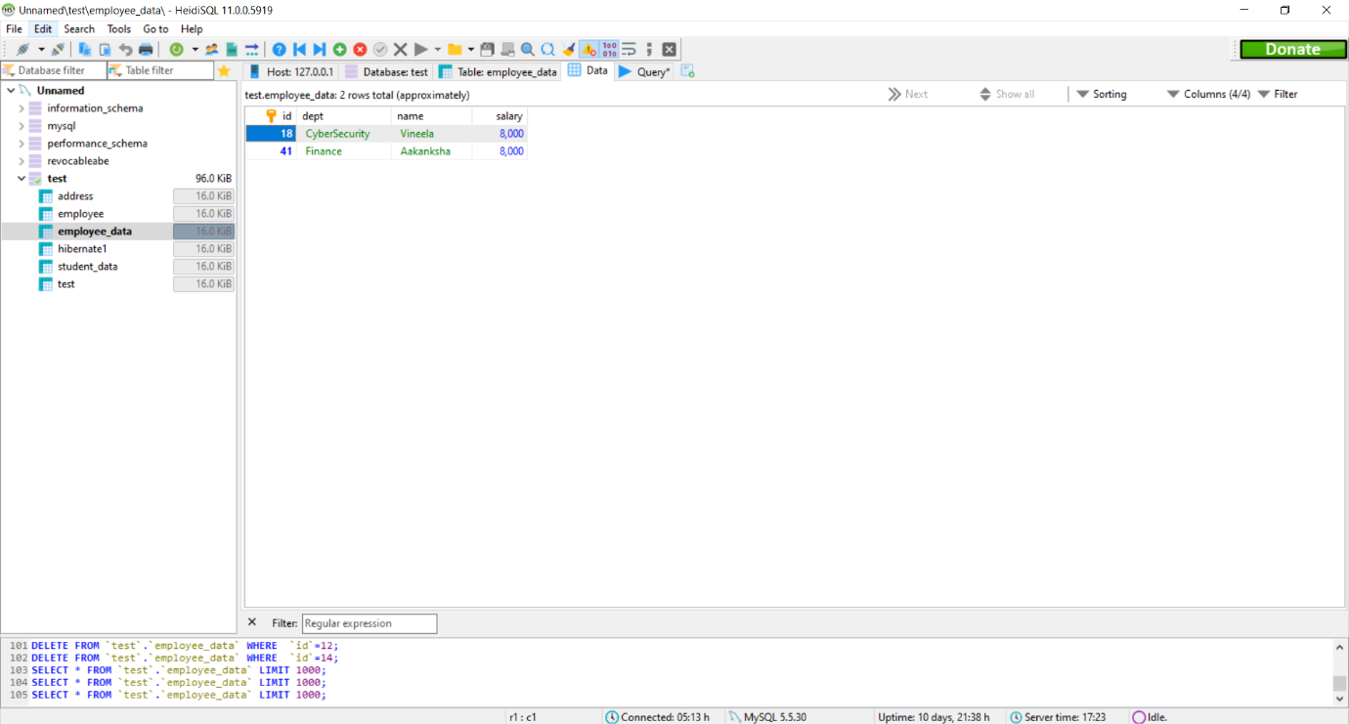

application.properties:

